ACTIVE WHEELCHAIRS WITH STANDING ABILITY

PROBLEM STATEMENT

India has 21,906,769 disabled, 6% of total population is elderly, india which is the yougest country now, would have more number of senior citizens by 2050. Although india has reached mars, the problems of disabled and elderly is still neglected.
"Whenever I get a wheelchair that doesn't suit me it leads to further problems", "I keep sitting on the same wheelchair 24*7 leading to further ailments, I have a wheelchair of zero after-sales service support", "Standing wheelchair that I use doesn't have proper strapping and is difficult to propel" - wheelchair users. A patient unless in a hospital undergoes a therapy called standing therapy, once he gets discharged he doesn't have access to standing devices and hence undergoes further ailments. There is a big need for customised wheelchairs as per individual fits which should be active and possess standing ability which should also be lightweight and easily transportable with the wheelchair improving the health. India has 2.1% of disability population, the majority in the minority population of India. Most wheelchairs are being imported to India.

EXISTING SOLUTIONS
ARISE STANDING WHEELCHAIRS
- only for therapeutical purpose
- 3 wheel system, difficult to propel indoors, people find difficult to take it inside homes
- total weight is 30Kgs, difficult to transport
- Low quality wheels and build quality.
- improper safety features

NEOMOTION- NEOFLY ACTIVE WHEELCHAIRS
- Not affordable by common person, starts at 35,000
- rigid frame, difficult to transport in public transportation
- after sales support is low
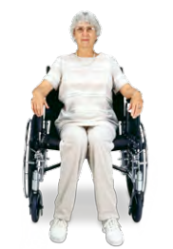
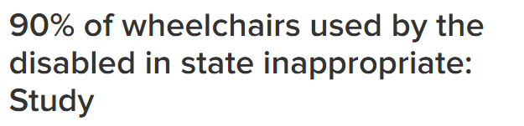
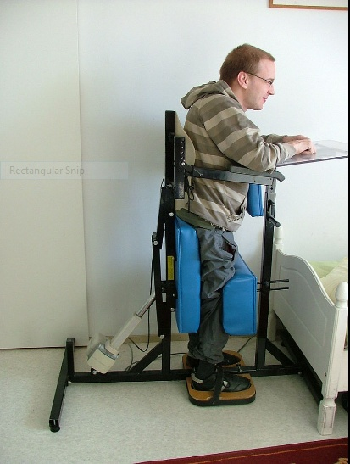

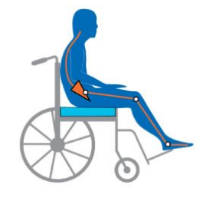

SOLUTION

SOLUTION

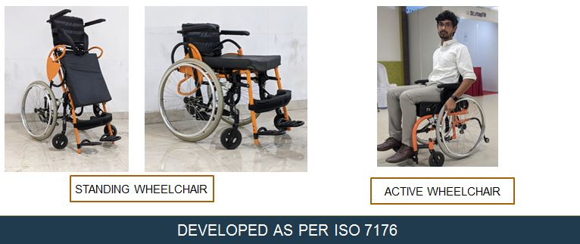

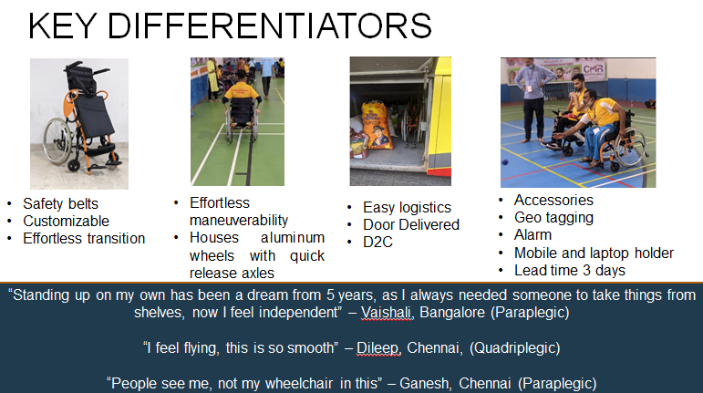

we develop active wheelchairs with standing ability to enhance independent living.
1. we provide customized wheelchair to individual fit
2.Total weight of the device is less than 15kgs
3.least force to translate from sitting to standing without aid of anybody else
4.wheel position and quality of wheels enhances maneuverability, the heart of the wheelchair
5.easiest bed transfers

6.Foldable, hence easily transportable
7."people see me and not my wheelchair when I use this wheelchair", "I feel moving with ease", I feel independent", user reviews on trials.
8. Enhances independent living, effective indoor and outdoor maneuverability
we are focusing on all spinal cord injury people, polio, stroke people, senior citizens and special children. Our wheelchairs would be tailor made, customized to individual fits. The users could translate at their own wish from sitting to standing. As we have made a active wheelchair with standing ability, the wheel position and quality of wheels enhances indoor and outdoor manoeuvrability. The stability and safety features make the users feel secured and make them independent. We are also creating a service chain across India, where you can get the wheelchair serviced within 12 hours. Our lead time for one order to be delivered across India would not be more than 4days.

PRODUCT COMPARISON

